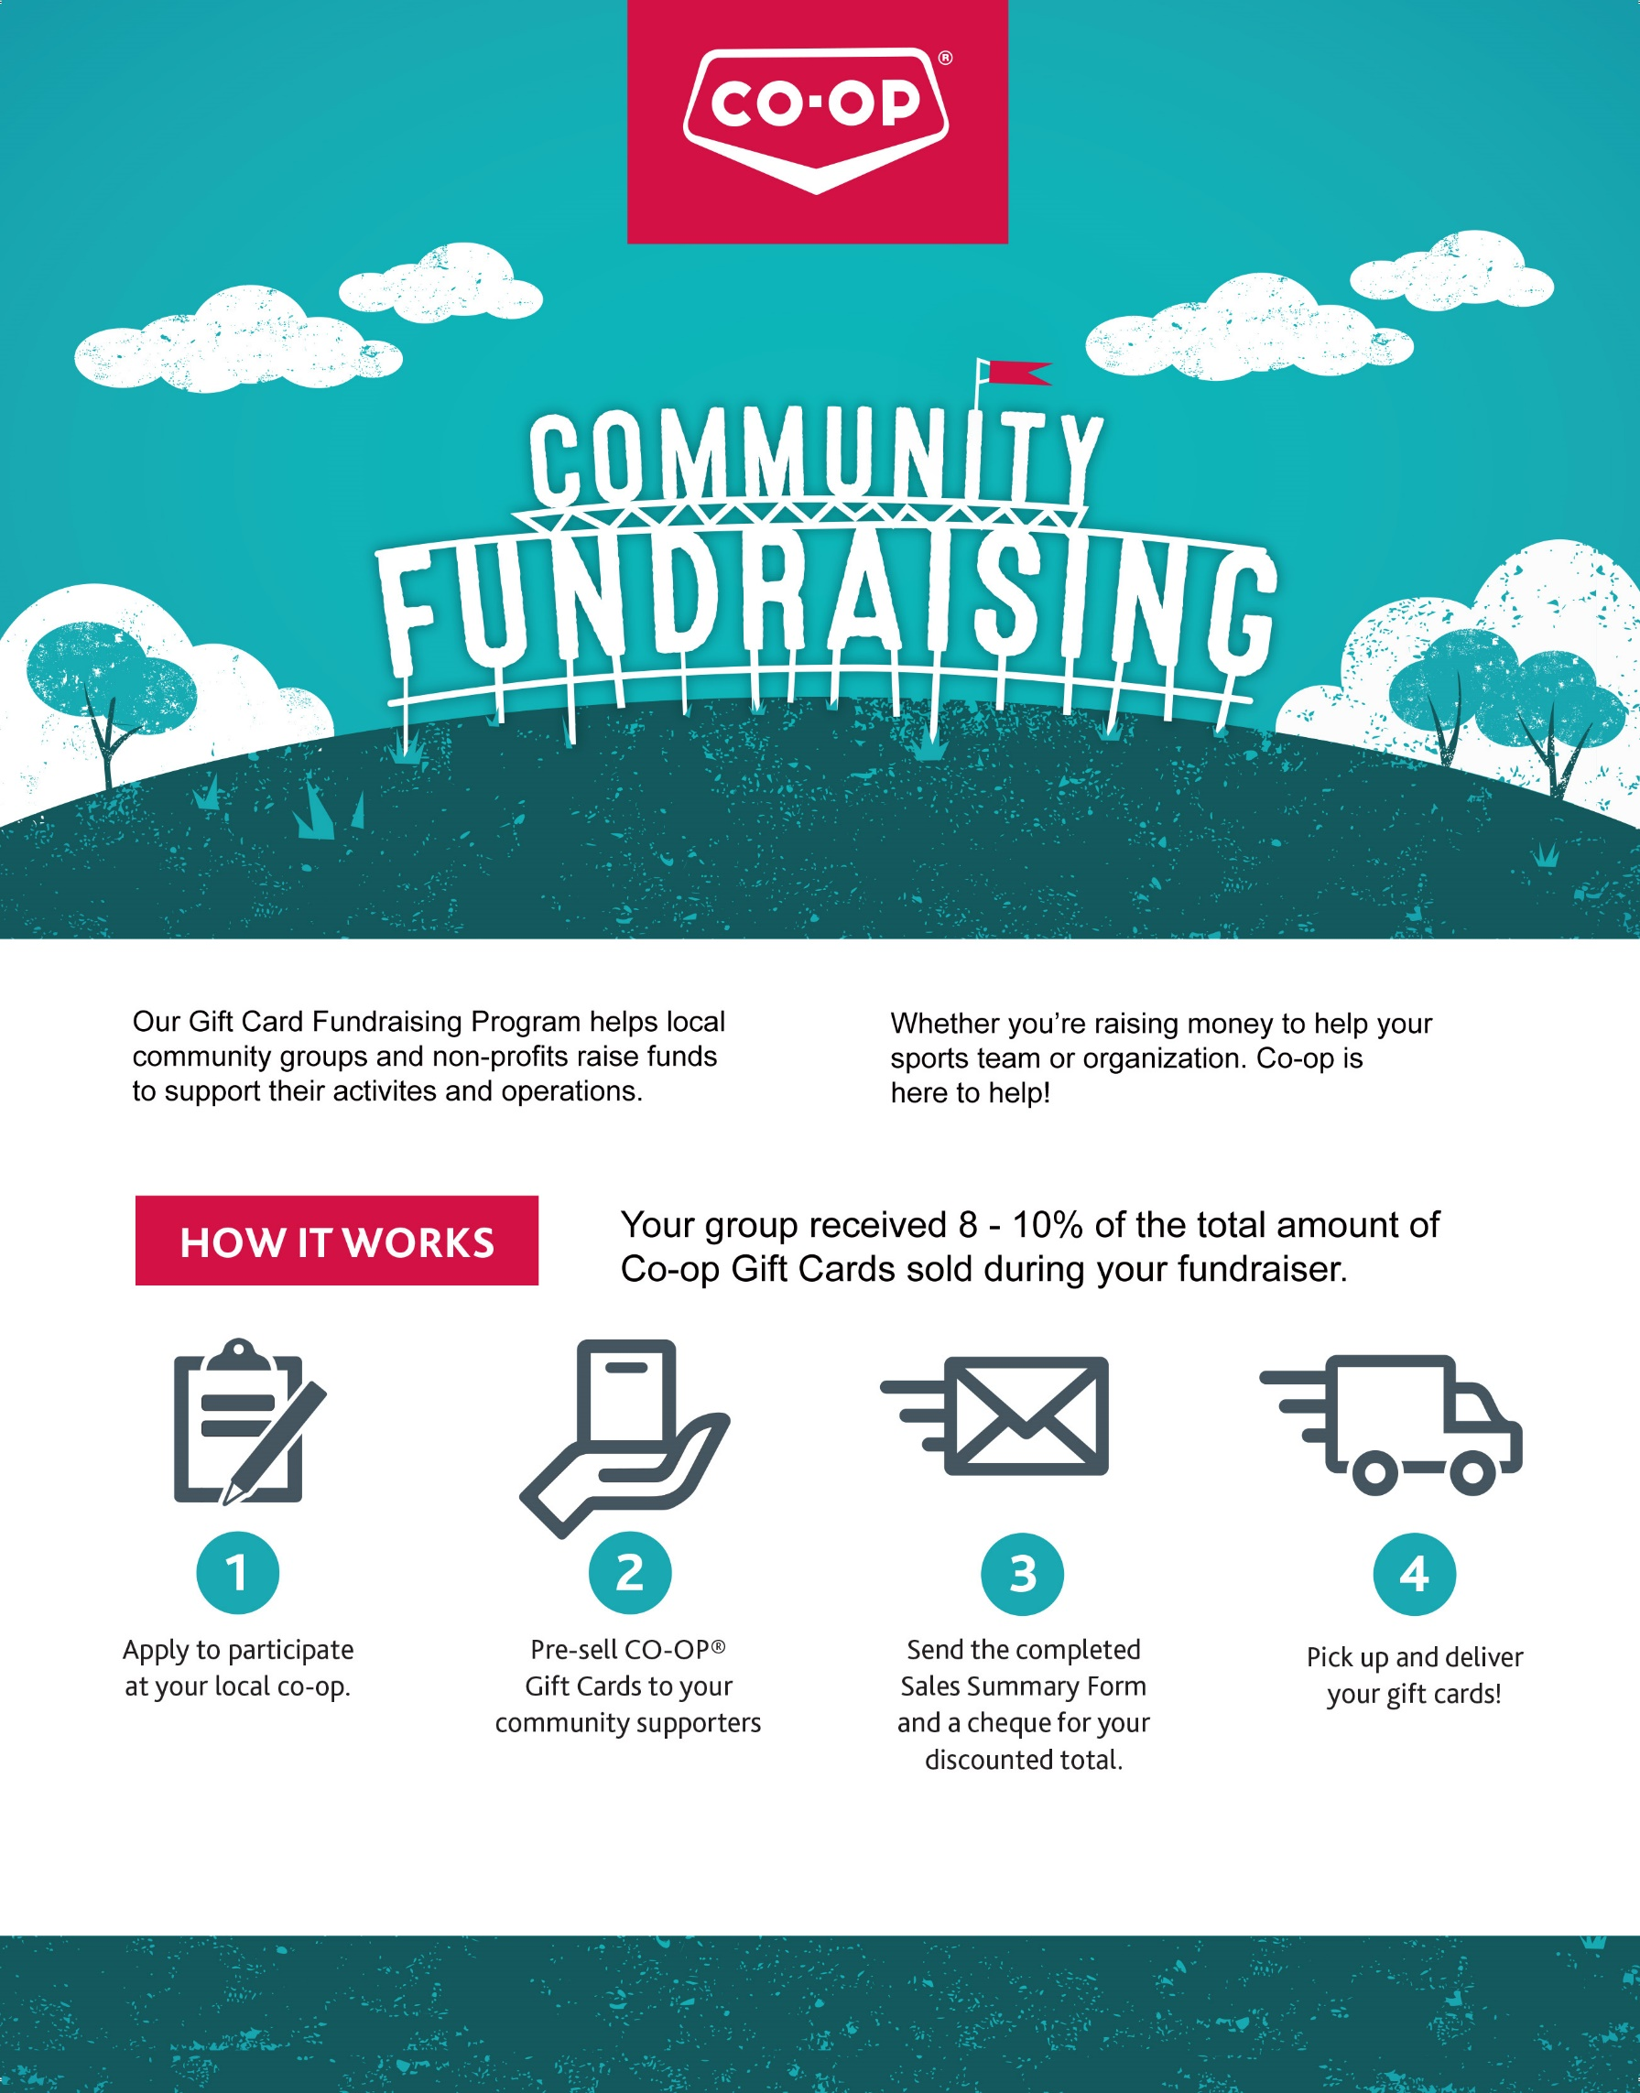

**GIFT CARD PROGRAM**

* 1. The intent of this program is for non-profit groups to raise funds from their group member’s **everyday purchases of vehicle fuel, groceries, and general merchandise**. It is also the intent of the gift card program to assist non-profit groups and organizations to raise funds to help families and children defray the costs of their activities. Examples would be sporting teams.
  2. Gift cards are available in increments of $25 (i.e. $25, $50, $100). Gift cards can be used during special promotions, events, and discount days.
  3. No minimum purchase is required. Gift cards are **“not redeemable for cash”.**
  4. The minimum order for gift cards is $2,500 on each occasion requested. Groups can run the program once per fiscal year.
  5. Non-profit organizations have the opportunity to raise funds by pre-selling the Co-op gift cards to friends, neighbors, co-workers, and family members. The non-profit group will receive a discount when purchasing the gift cards, based on the following grid:

$ 2,000 - $ 9,999 = 8%

$ 10,000 - $50,000 = 10%

Example: A hockey team of 20 players sells $750 each in gift cards. An invoice will be generated for a total of $15,000 less a 10% discount = $13,500. The group collects $15,000 and is invoiced $13,500. The remaining $1,500 is your fundraised amount. The more gift cards that you sell, the more funds you will raise. Payment to the Co-op can be made by cash, bank draft or certified cheque.

* 1. Gift cards will be used for everyday consumer goods, i.e. food, pharmacy, pump gas, tobacco, hardware, and general merchandise. Gift cards **cannot be used for payment on account, bulk petroleum, propane, cardlock, crop protection, fertilizer, grain bins, livestock equipment, bulk feed or other gift cards.**
  2. Anyone who purchases a gift card will make payment to the organization. The organizer would then deposit all funds received into the club’s account. The club will then let the Co-op know the number of cards required in each denomination, as per the attached request form. The Co-op would then generate an invoice with the discounted amount and get the gift cards ready. (Please allow 3 working days for the Co-op to gather the order together). Payment to the Co-op is to be made prior to release of gift cards.
  3. A sales blitz can be organized by clubs any time during the year. You may wish to plan your sales drive around key times of the year when people are more likely to buy larger quantities of groceries, gas, etc. (Christmas, Easter, Thanksgiving). The gift cards are normally used within a few weeks of receiving them. Once you have a list of people purchasing the gift cards, they are more likely to re-purchase the next time and the fundraiser then becomes more successful.
  4. The applications for this fundraiser are endless. We welcome all non-profit groups and organizations to participate and we feel there is an opportunity for groups to make a substantial amount of money from this fundraiser. Who doesn’t buy gas or groceries? The key to success in this program is to ensure all individuals within your group are on board. Substantial funds can be raised by making a few telephone calls from your kitchen table. We realize that your time is valuable and that the Co-op also benefits from this program. We feel this is a win-win situation by providing you with a fundraising idea and providing us with a customer through our doors.

**SALES FORM INFORMATION**

It is the responsibility of the fundraising group to deliver the correct gift cards to their purchasers.

**GIFT CARD TERMS AND CONDITIONS**

Use of gift cards is subject to the terms and conditions expressed on the back of each card. Gift cards can be used for everyday consumer goods at time of purchase, e. g. fuel, food, pharmacy, hardware and general merchandise purchases. Gift cards cannot be used for payment on account, bulk fuel, cardlock, crop protection, fertilizer, grain bins, livestock equipment, bulk feed, or gift cards.



***\*\*Please Note that the amount that you receive through the gift card program maybe Meadow Lake Co-op’s donation to your organization, for the year. At this time, due to fiscal restraints, if you choose to use the gift card program, the Meadow Lake Co-op is unable to donate anything beyond the proceeds of the gift card program to your organization.***



**SALES**

**SUMMARY**

**FORM**

Thank

you

for

choosing

Co

-

op

for

your

fundraiser!

Please

return

this

completed

form

to

**the**

**Meadow**

**Lake**

Co

-

op.

Fundraising

Group

Name:

Organizer

Phone

Number:

Organizer

Name:

Date

Submitted to

Co

-

op:

Organizer

Email:

Organizer

Signature:

**SELLER**

**NAME**

**TOTAL**

**NUMBER**

**OF**

**CARDS**

**SOLD**

**#**

**OF**

**$25**

**CARDS**

**#**

**OF**

**$50**

**CARDS**

**# OF $100**

**CARDS**

**TOTAL DOLLAR**

**AMOUNT**

TOTALS

TOTAL

DOLLAR

AMOUNT:

................................

................................

................................

....

$

8

or

10

%

DISCOUNT

OF

THE

ABOVE

TOTAL:

(maximum $5,000)

..........................

.

%

.

......

CHEQUE

TO

CO

-

OP

(subtract

your

discount

from

the

total

sold):

$

................................

.........

$

Please

make

your

cheque

payable

to

the

Meadow

Lake

C

o

-

op.

Postdated

cheques

are

not

accepted.

Note

that

the

cheque

must

be

from

your

organization.

Personal

cheques,

cash

and

credit

cards

are

not

accepted.



**GIFT**

**CARD**



We’ve partnered with the Meadow Lake Co-op to help us reach our fundraising goal. For every Co-op Gift Card we sell, we keep 8% if we sell between $2,000 and $9,999 worth of gift cards and 10% if we sell more than $10,000 worth of gift cards. Meadow Lake Co-op will donate a maximum of $5,000.00 to our organization.

Gift cards are available in amounts of $25, $50 and $100 and can be used for everyday purchases such as gas, groceries, service center and more!

This means our regular shopping trips can support our fundraiser!

How it works:

1. You buy Co-op Gift cards for face value and get face value.

2. Each gift card you purchase automatically includes an 8 or 10% donation to our group from the Co-op.

3. Shop at Co-op locations as you normally would for gas, groceries and home needs.

4. Pay with your fundraising gift card.

More reasons why Co-op Gift Cards are a great purchase:

* 100% of the profits from your local co-op stay in your community.
* They make great gifts for friends and family.
* Donations towards our fundraiser can add up quickly.
* Co-op members can earn equity and cash back annually on their purchases.

Gift cards will be used for everyday consumer goods, i.e. food, pharmacy, pump gas, tobacco, hardware, and general merchandise. Gift cards **cannot be used for payment on account, bulk petroleum, propane, cardlock, crop protection, fertilizer, grain bins, livestock equipment, bulk feed or other gift cards.**

Buy a Co-op gift card and support us today!

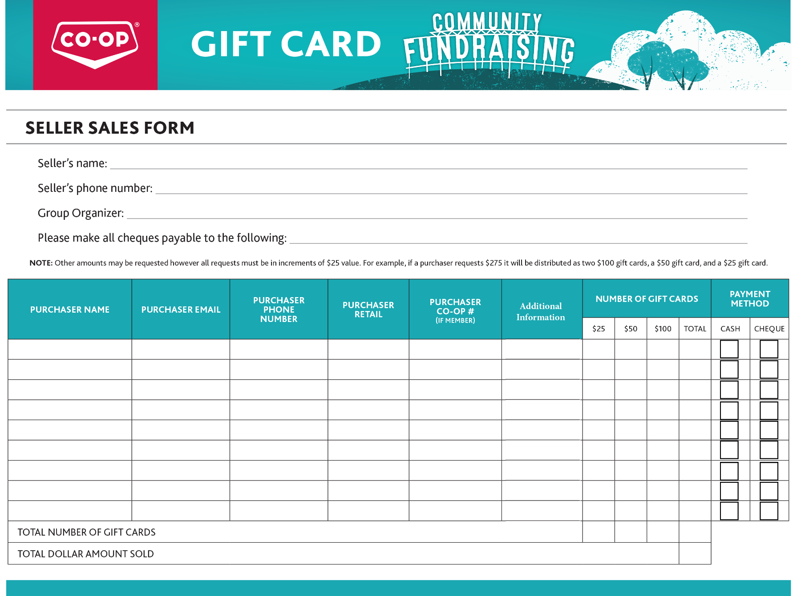

No minimum purchase is required. Gift cards are **not redeemable for cash.**

Gift cards will be used for everyday consumer goods, i.e. food, pharmacy, pump gas, tobacco, hardware, and general merchandise. Gift cards **cannot be used for payment on account, bulk petroleum, propane, cardlock, crop protection, fertilizer, grain bins, livestock equipment, bulk feed or other gift cards.**