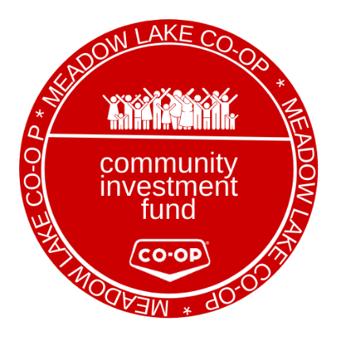
COMMUNITY
INVESTMENT
FUND

*4 community organizations will be given $5,000.00 per year.

Donations
Co-ops are built by and for the communities they serve. Meadow Lake Co-op supports causes that are important to members, team members and their communities including a large number of local charitable organizations and sports teams. Over $100,000 is donated to various organizations and groups every year.
Meadow Lake Co-op takes extreme pride in being able to give back to our communities. We owe our success to our members and our customers, who purchase our products and services. Therefore, it is very important to our organization that we are committed to contributing to the betterment of our community, our members and our team members.
Meadow Lake Co-op, as part of the Co-operative Retailing System, is also proud to be involved in campaigns to raise funds and awareness for important ventures like the Children’s Hospital Foundations of various provinces, the Canadian Breast Cancer Foundation and the Canadian Red Cross.
Please review the Sponsorship Guidelines below.
Program Guidelines/Eligibility
- Groups must reside and be active in our trading area
- All requests must be submitted in writing or online, using the forms provided
- Gift cards and donations of product will be considered as appropriate
- Meadow Lake Co-op must receive recognition for the contribution

Limitations on Giving
Meadow Lake Co-op will provide support to those groups which best match the organizations values and objectives. The following are not normally supported:
- Political parties/organizations
- Individuals, self-interest groups
- Third party fund raisers, unless recognition is given to Meadow Lake Co-op
- Religious and sectarian organizations, except for community services offered on a nondenominational basis
- Professional or technical associations
- Private Clubs
- Any organization involved in promoting morally controversial issues
- Conferences, training sessions, seminars, workshops, conventions and retreats
- Trips and tours

Contributions will normally be restricted to a one-time only donation during any fiscal year.
Applications will be open from January 1 to February 28 of any given year. All organizations will be contacted regarding the status of their application once the decision has been made as to which 4 organizations will receive the yearly Community Investment.

All application must be received at the Meadow Lake Co-op Administration Office prior to March 1 of the current year.

