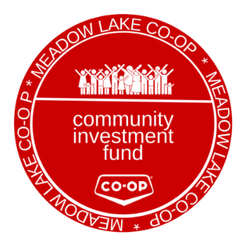
COMMUNITY INVESTMENT
FUND APPLICATION FORM

Project/Program Name
Organization/Charity Name
Street Address
City
Province
Postal Code
Phone Number
Website
What is the primary community that your program/event will support?
What type of organization is applying? |  | An organization registered as having charitable status by the Canada Revenue Agency
 |  | A provincially registered not-for-profit
Is your funding request professional sports related or for a religious or political organization |  | Yes
 |  | No
Requested funding amount
(max. $5,000.)
Preferred form of support |  | Cash
 |  | Co-op Gift Card
 |  | In-kind Product (ie: food donation)
Event/program start date
Event/program end date
Have you ever received funding from the Meadow Lake Co-op in the past? |  | Yes
 |  | No
Are Meadow Lake Co-op Team Members involved in this organization? |  | Yes
 |  | No
How did you hear about our Community Investment Fund?
Event Description/purpose of funding
Please detail how Meadow Lake Co-op’s contribution will be spent
Please detail how Meadow Lake Co-op’s contribution will be recognized
Additional comments/information
Office use
Date Received:
Reviewed by:
Comments:
Approval Date:
Approved by:
Please forward application to the Meadow Lake Co-op Administration Office

